JIFUNZ SQL MIN PROJECT

NAME: VICTOR ELUBA

STUDENT ID: VE007

JULY 2023

\*Question 1:

Provide the top 10 customers (full name) by revenue, the country they shipped to, the cities and their revenue (orderqty \* unitprice).

\*/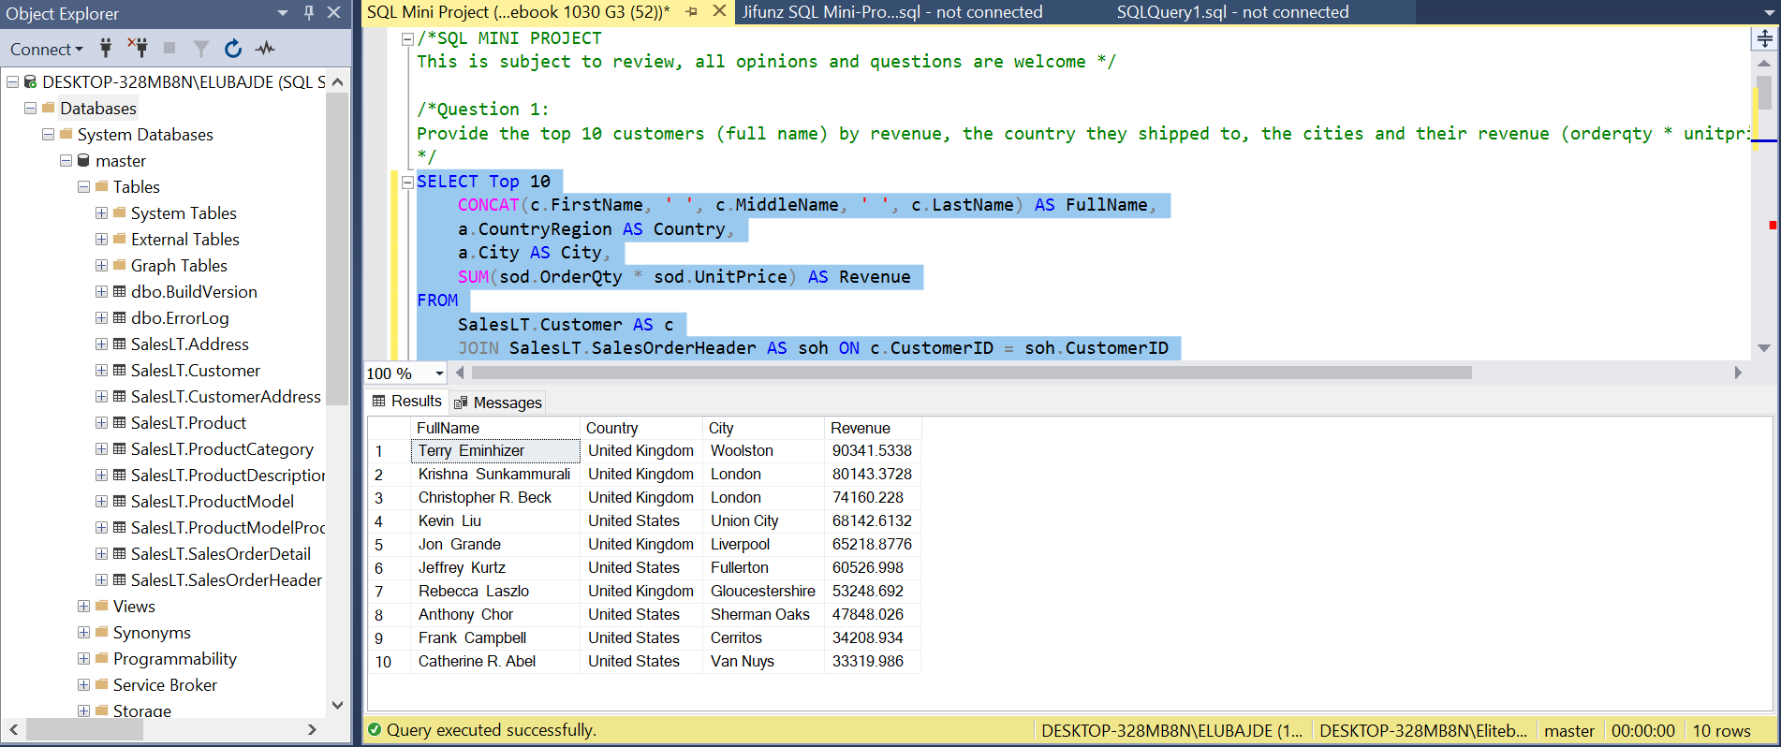

By identifying the top revenue-generating customers, the marketing team can gain insights into the most valuable customers in terms of their purchasing power. This information allows them to prioritize their efforts and allocate resources towards retaining and nurturing these high-revenue customers. The team can design personalized loyalty programs, tailored offers, exclusive rewards, or targeted marketing campaigns to strengthen customer loyalty, enhance the customer experience, and potentially increase customer lifetime value. Additionally, understanding the shipping country and city of these top customers can provide valuable geographic insights, enabling the marketing team to focus on specific regions or tailor marketing efforts to reach similar customer segments in other areas.

/\*Question 2:

Create 4 distinct Customer segments using the total Revenue (orderqty \* unitprice) by customer.

List the customer details (ID, Company Name), Revenue, and the segment the customer belongs to.

\*/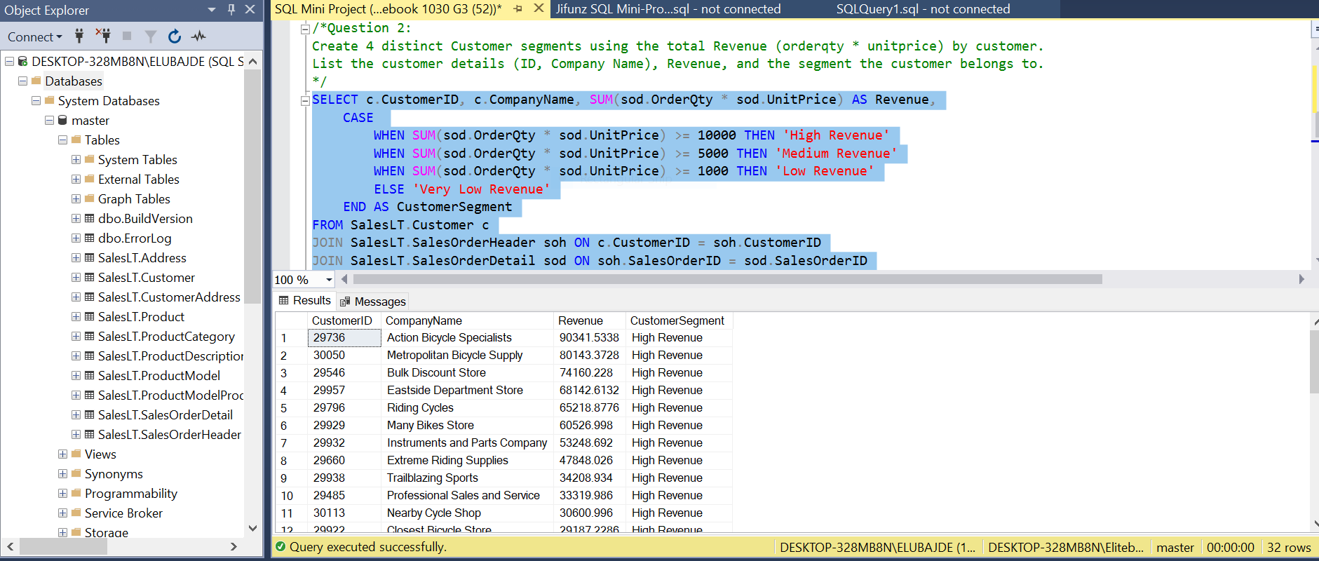

By segmenting customers based on their revenue levels, the marketing team can tailor their loyalty program strategies and initiatives to address the specific needs and preferences of each segment. The segmentation allows them to identify high-revenue customers who may require personalized VIP treatment, exclusive benefits, and premium rewards to further enhance their loyalty. For customers in the medium revenue segment, the team can design strategies to nurture their loyalty and incentivize them to increase their spending. Similarly, for customers in the low and very low revenue segments, targeted initiatives can be implemented to encourage repeat purchases and gradual growth in their spending. This approach enables the marketing team to allocate their resources effectively and deliver customized experiences that resonate with each customer segment, fostering long-term loyalty and maximizing customer lifetime value.

/\*Question 3:

What products with their respective categories did our customers buy on our last day of business?

List the CustomerID, Product ID, Product Name, Category Name, and Order Date.

\*/

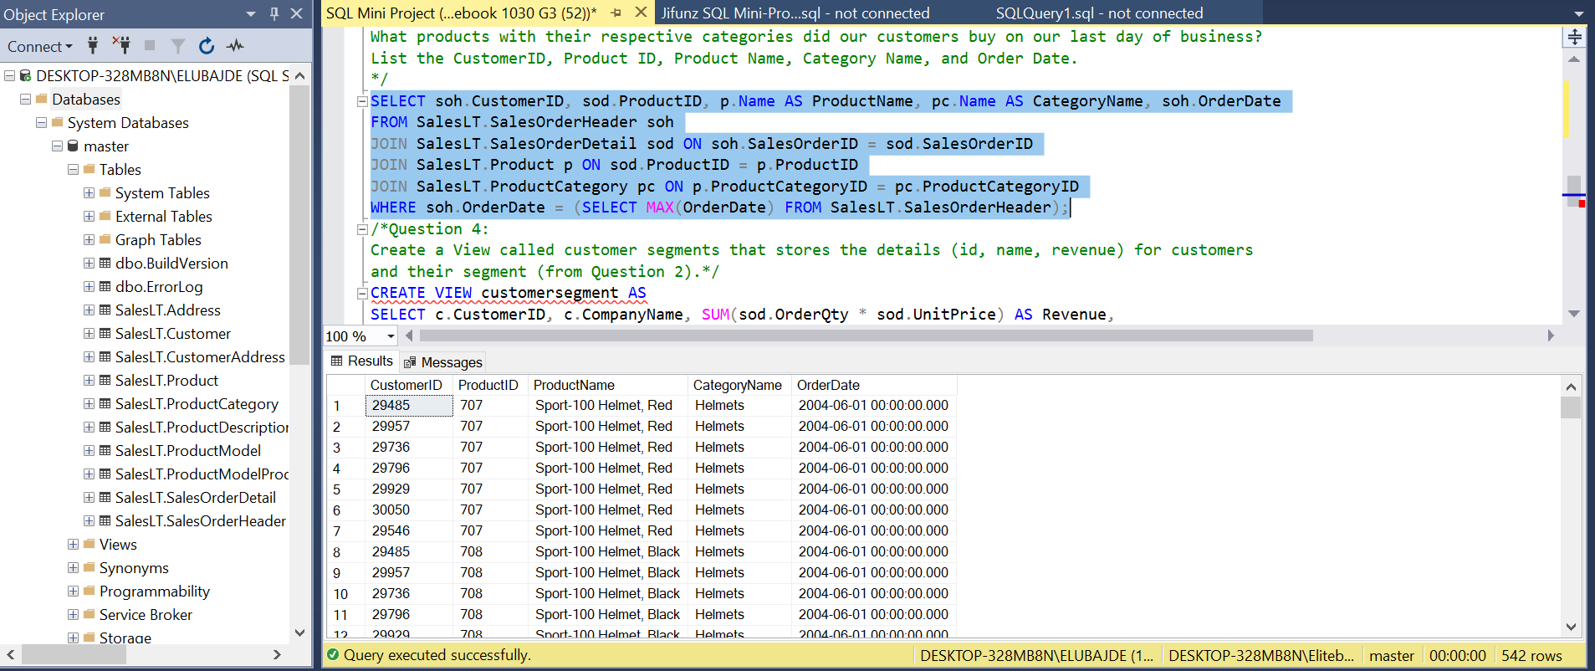

By analyzing the specific products and categories purchased on the final day of business, the marketing team can gain insights into the preferences and interests of their customers during that time. This information allows them to tailor their loyalty program offerings, rewards, and promotions to align with those specific product categories or similar items. By understanding the customer's recent purchasing behaviour, the marketing team can design targeted campaigns, personalized recommendations, and incentives related to the products and categories that were popular on the last day of business. This approach helps to engage customers by offering them relevant and appealing loyalty program benefits, ultimately driving customer satisfaction, loyalty, and potential repeat purchases.

/\*Question 4:

Create a View called customer segments that stores the details (id, name, revenue) for customers

and their segment (from Question 2).\*/

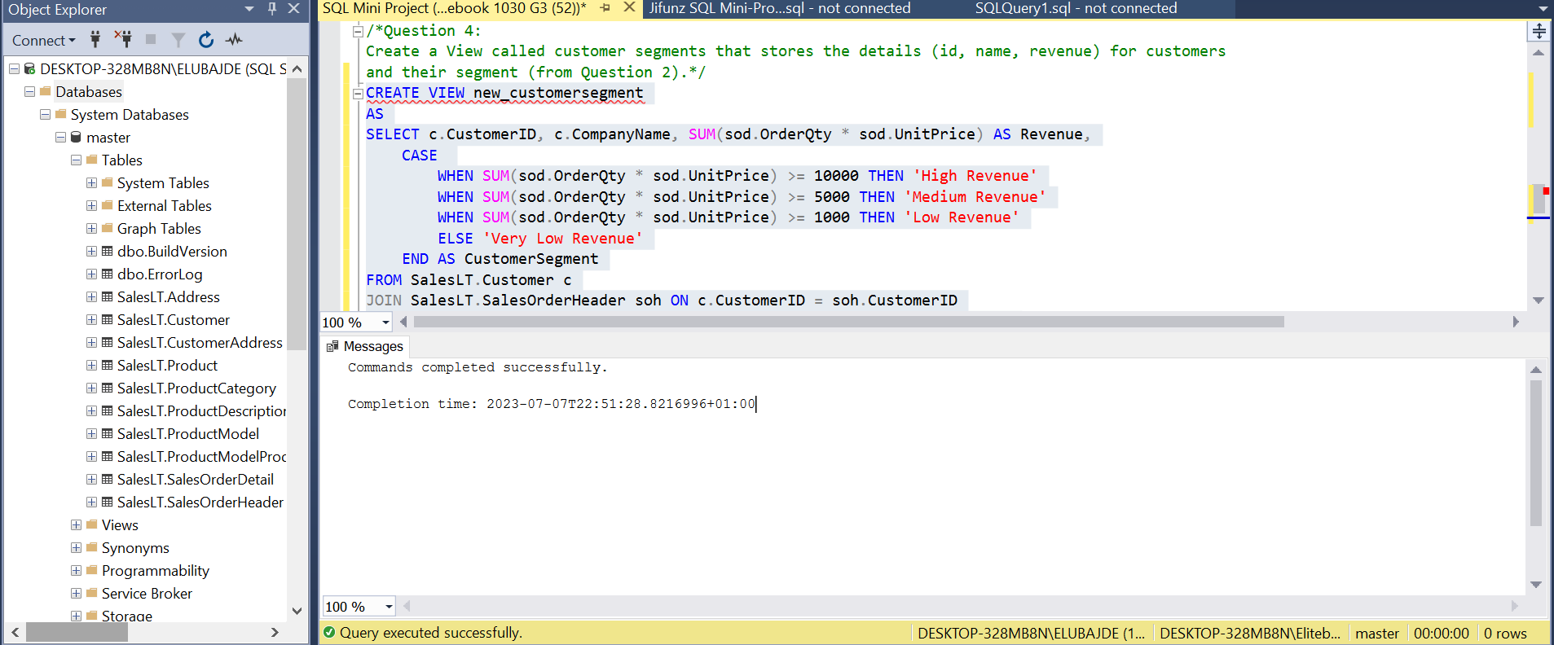

By having this view readily available, the marketing team can easily access and analyze the key information required to understand each customer's revenue contribution and their assigned segment. This data empowers the team to segment their customer base effectively and personalize their loyalty program strategies based on customers' revenue levels. It enables the marketing team to target high-revenue customers with exclusive benefits, incentives, and rewards to reinforce their loyalty and drive further business growth. Additionally, they can focus on specific segments, such as medium or low revenue, by designing initiatives to encourage increased spending, repeat purchases, and incremental growth in revenue. The view provides a consolidated and easily accessible snapshot of customer revenue and segmentation, enabling the marketing team to make data-driven decisions and implement a more targeted and impactful customer loyalty program.

/\*Question 5:

What are the top 3 selling products (include product name) in each category (include category name)

by revenue? Tip: Use ranknum.

\*/

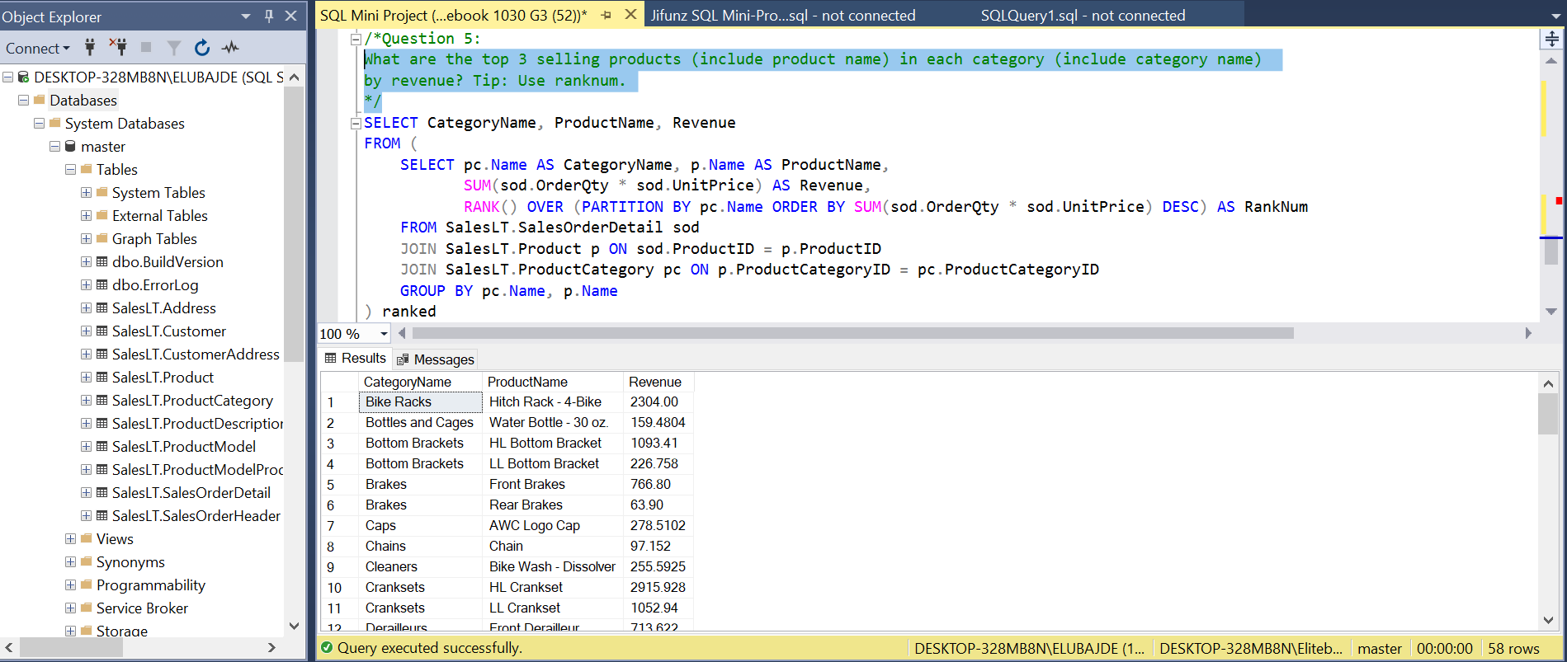

By analyzing the highest revenue-generating products in each category, the marketing team can identify the most popular and successful products within their customer base. This information allows them to strategically align their loyalty program offerings, rewards, and promotions with these top-selling products. By focusing on these high-performing products, the marketing team can attract customer attention, generate increased interest, and drive higher engagement with their loyalty program. Additionally, this knowledge helps in designing targeted marketing campaigns, cross-selling or upselling initiatives, and product-specific incentives to enhance customer loyalty and encourage repeat purchases. By leveraging the top-selling products within each category, the marketing team can tailor their loyalty program to align with customer preferences and drive overall customer satisfaction and loyalty.